CSA1708-ARTIFICIAL INTELLIGENCE
LAB EXPERIMENTS
Program 7 : Python Program to Implement Breadth-First Search (BFS)
Aim
To develop a Python program to implement the Breadth-First Search (BFS) graph traversal algorithm using a queue data structure to visit all nodes level by level.
Algorithm
1. Represent the graph using an adjacency list implemented as a Python dictionary.
2. Select an initial source vertex to commence the traversal.
3. Initialize a First-In-First-Out (FIFO) queue and enqueue the starting vertex.
4. Initialize a visited list to keep track of explored vertices, marking the starting vertex as visited.
5. While the queue is not empty:
6. a. Dequeue the front vertex from the queue.
7. b. Append the vertex to the traversal sequence.
8. c. For each adjacent neighboring vertex of the dequeued vertex:
9. i. If the neighbor has not been visited, mark it as visited and enqueue it into the queue.
10. Continue until all reachable vertices have been explored and the queue becomes empty.
11. Display the complete sequence of vertices visited in BFS order.

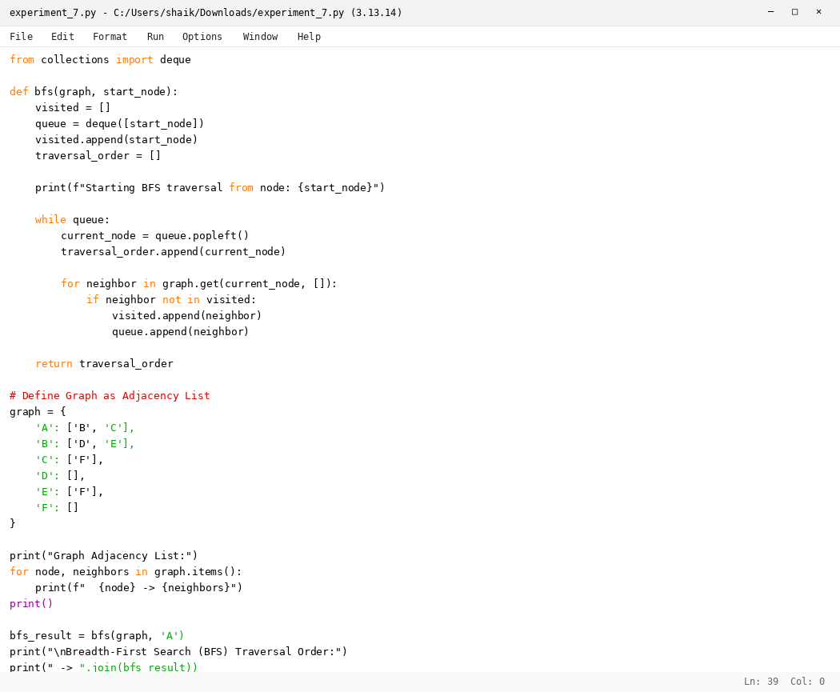

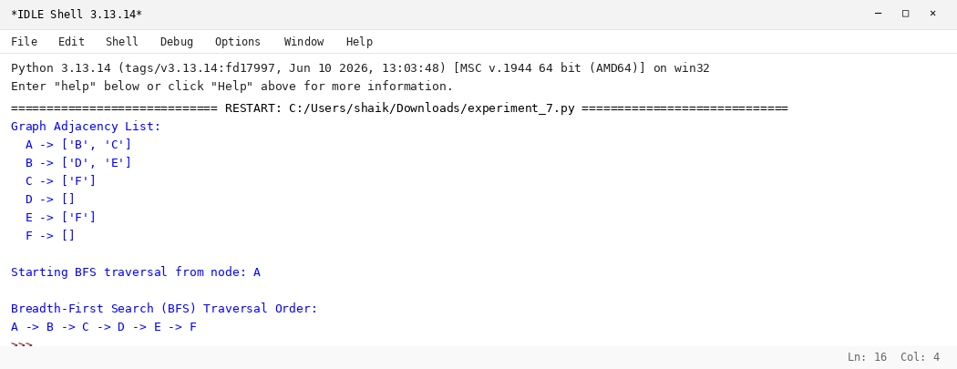

RESULT
Thus, the Breadth-First Search (BFS) algorithm was implemented successfully using Python.

